Parking Lot Program Process

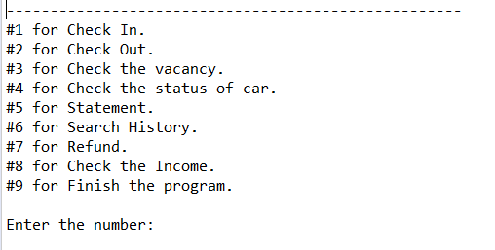

//This is main page.

1. For check in.

You can choose any size of car.

Then, you can choose a spot.

If the spot is empty, you can input all the information about driver.

Else, program will show you an error. Retry.

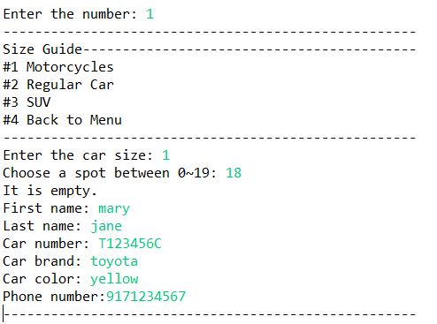

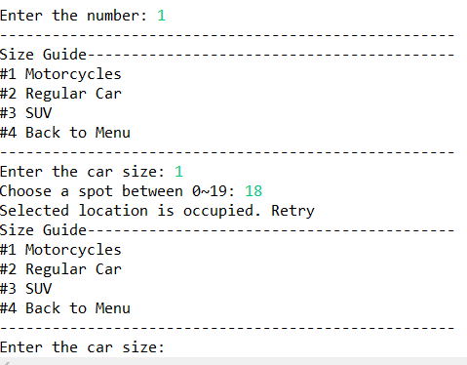

* When you check in, it will save the data into Oracle database system.

1. For check the vacancy.

You can choose any size of car that you try to park.

Total number of spots for size 1 is 20, size 2 is 50, and size 3 is 30.

In this case, we parked a motorcycle into spot # 18 so. 19 spots for size 1.

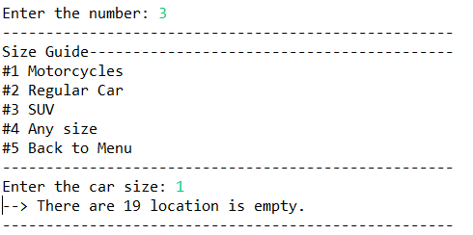 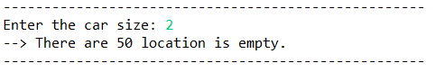 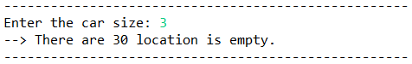 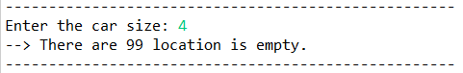

1. For check the status of currently parking car.

You can search the status by location number, full name, or car number.

Let’s try search by full name.

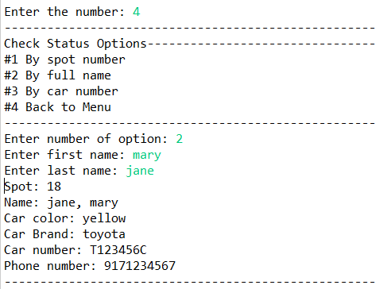

1. For check out.

Let’s check out.

When you choose to check out, it requires you to input the location number.

If you input the number, it will check.

If that spot is empty, you need to try again.

Else, check out process and it will update the bill.

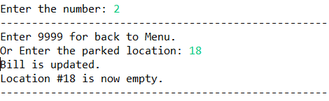

1. For statement.

You will have 3 option for check your statement.

Bill, customer, and refund history.

Let’s check bill history.

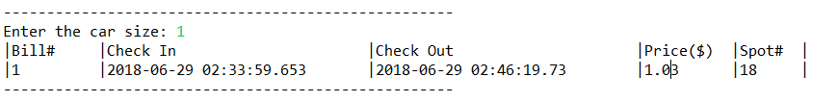

It charged $1.03 based on how long the customer stay (hourly).

I set the price as $4.99 for size#1, $8.99 for size #2, and $17.99 for size#3 for hourly price.

Also, it saves the customer’s data into customer table.

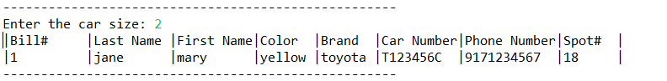

1. For refund.

for refund the money, you should know bill number. If you input bill number that does not exist, it will show you the error.

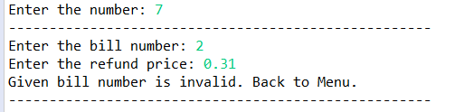 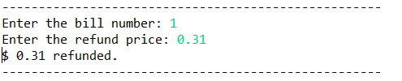

After this, let’s check the refund history.

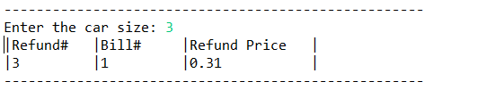

1. For search history.

You can look up customer history by name, phone number, or car number.

You also can look up bill history by bill number.

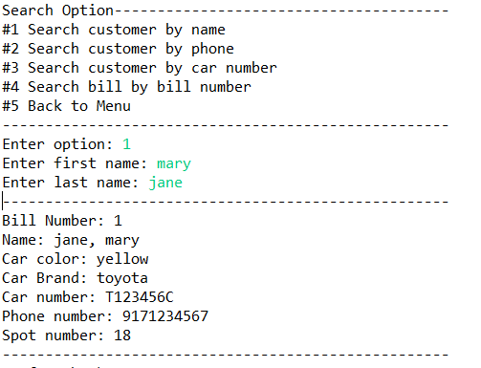

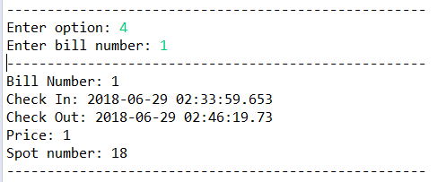

1. For check the income.

You can check your income.

